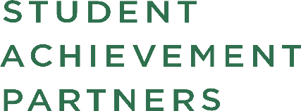 |  | 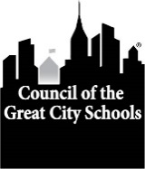

June 24, 2020 For Information: Tonya Harris
(202) 393-2427, tharris@cgcs.org

National Education Groups Lay Out Blueprint for Instructional Priorities and Strategies for Upcoming School Year
Guidance Emphasizes Importance of Addressing Unfinished Learning in the Context of Grade-level Work
Student Achievement Partners and the Council of the Great City Schools today released the following companion documents laying out a blueprint for schools across the country to get the nation’s schoolchildren back on track academically after a disrupted school year.
- 2020–21 Priority Instructional Content in English Language Arts/literacy and Mathematics (www.achievethecore.org/2020-21_PriorityInstructionalContent)
- Addressing Unfinished Learning After COVID-19 School Closures https://tinyurl.com/ya4g73f9
The complementary resources identify grade-level instructional priorities in math and literacy for the 2020-21 school year and describe how schools can recognize and address unfinished learning among their students while ensuring equitable access to grade-level standards and mental health supports.
The two national organizations stress that, while students will have incomplete learning from this school year, resorting to extensive testing, reteaching, and remediation at the expense of grade-level work will further jeopardize the academic success of students, particularly those with specialized learning needs.
The documents, which were developed in tandem with teams of national experts in math and literacy, articulate the rationale for sustaining a focus on grade-level work; outline a set of streamlined, high-leverage standards and topics; and address ways to support the social and emotional development of students. The blueprints also describe specifically how unfinished learning can manifest itself and what teachers can do in math and literacy to address gaps without losing instructional momentum.
The materials were developed by the two partner organizations to help school districts across the county address the incomplete education that many students received over the course of the last school year and keep students on track with their studies in the years to come.
Student Achievement Partners is a nonprofit organization dedicated to improving achievement for all K-12 students nationally.
The Council of the Great City Schools is a coalition of 76 of the nation’s largest city public school districts.

